# Relatório - ST6: Projeto de Filtro FIR Band-Stop

## 1. Enunciado

## 2. Código Python

import numpy as np  
import pandas as pd  
import matplotlib.pyplot as plt  
from scipy.signal import freqz  
  
  
fs = 10000  
fc1 = 2500  
fc2 = 3500  
M = 4  
n = np.arange(M + 1)  
center = M / 2  
  
  
wc1 = np.pi * fc1 / (fs / 2) # π/2  
wc2 = np.pi * fc2 / (fs / 2) # 0.7π  
  
  
def sinc(w, n, center):  
 result = np.zeros_like(n, dtype=float)  
 for i in range(len(n)):  
 x = n[i] - center  
 if x == 0:  
 result[i] = w / np.pi  
 else:  
 result[i] = np.sin(w * x) / (np.pi * x)  
 return result  
  
  
term_allpass = sinc(np.pi, n, center)  
term_wc2 = sinc(wc2, n, center)  
term_wc1 = sinc(wc1, n, center)  
  
  
q = term_allpass - term_wc2 + term_wc1  
  
  
q_normalizado = q / np.sum(q)  
  
  
for i in range(len(n)):  
 print(f"n = {n[i]} -> All-Pass = {term_allpass[i]:.6f}, Sinc(wc2) = {term_wc2[i]:.6f}, Sinc(wc1) = {term_wc1[i]:.6f}, q[n] = {q[i]:.6f}, q[n] norm = {q_normalizado[i]:.6f}")  
  
  
title = "Resposta em Frequência - Filtro ST6"  
w, h_response = freqz(q_normalizado, worN=8000)  
frequencies = w * fs / (2 * np.pi)  
plt.figure(figsize=(8, 4))  
plt.plot(frequencies, 20 * np.log10(np.abs(h_response)))  
plt.axvline(x=2500, color='red', linestyle='--', label='2500 Hz')  
plt.axvline(x=3500, color='red', linestyle='--', label='3500 Hz')  
plt.title(title)  
plt.xlabel("Frequência (Hz)")  
plt.ylabel("Magnitude (dB)")  
plt.grid(True)  
plt.legend()  
plt.tight_layout()  
plt.show()

## 3. Resultato

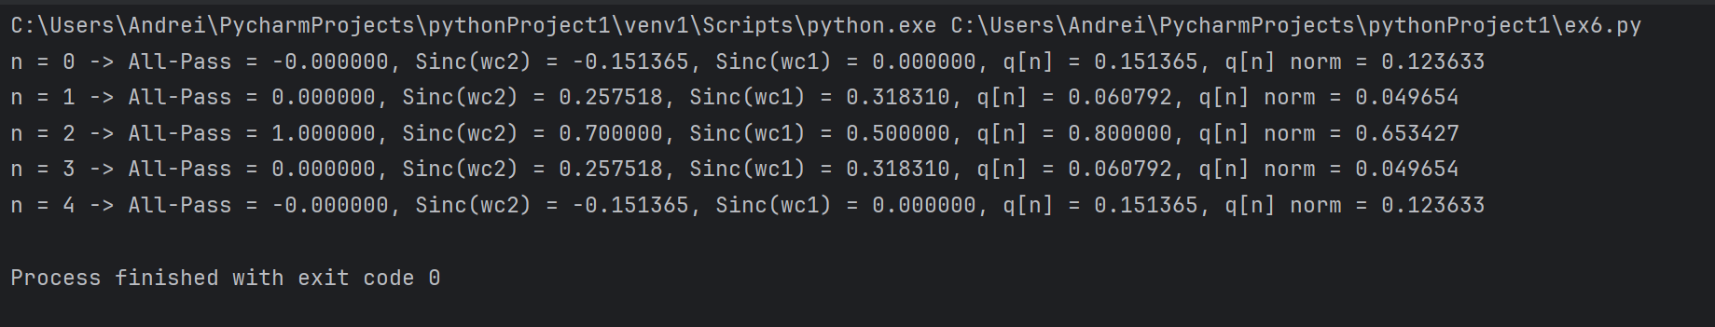

## 4. Gráfico da Resposta em Frequência

